# Creating a New User in ECC or S4/HANA

## Navigate to SU01

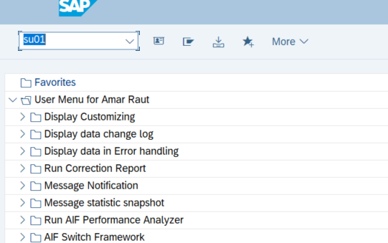

## Creating the User

Creating a new User gives the new user and we will refer to the user to copy all the roles to assign to this new user click on the copy button.

Enter a new username.

## Copying all the roles to new users.

The user will copy all the roles of the existing to the new user.

New user

Existing user

## Assigning roles to user conformation

Just confirm all the roles which we have assigned to the user.

## Conforming the reallocated roles.

## Assigning User Credentials.

## Create a Password and save the credentials.

## Giving SAP ALL role to User.

### Navigate to SU01 tcode.

### Select the User.

### Navigate to Profiles.

Select SAP_ALL in profile and click enter and then save it

